**Spiekblad Rekenen**

|  |  |  |  |  |  |  |  |  |  |
| --- | --- | --- | --- | --- | --- | --- | --- | --- | --- |
|  |  |  |  |  |  |  |  |  |  |
|  |  |  |  |  |  |  |  |  |  |

0 1 2 3 4 5 6 7 8 9 10

|  |  |  |  |  |  |  |  |  |  |  |  |  |  |  |  |  |  |  |  |
| --- | --- | --- | --- | --- | --- | --- | --- | --- | --- | --- | --- | --- | --- | --- | --- | --- | --- | --- | --- |
|  |  |  |  |  |  |  |  |  |  |  |  |  |  |  |  |  |  |  |  |
|  |  |  |  |  |  |  |  |  |  |  |  |  |  |  |  |  |  |  |  |

0 1 2 3 4 5 6 7 8 9 10 11 12 13 14 15 16 17 18 19 20



**3 + 2 = 5**

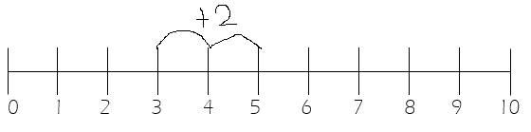

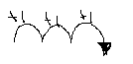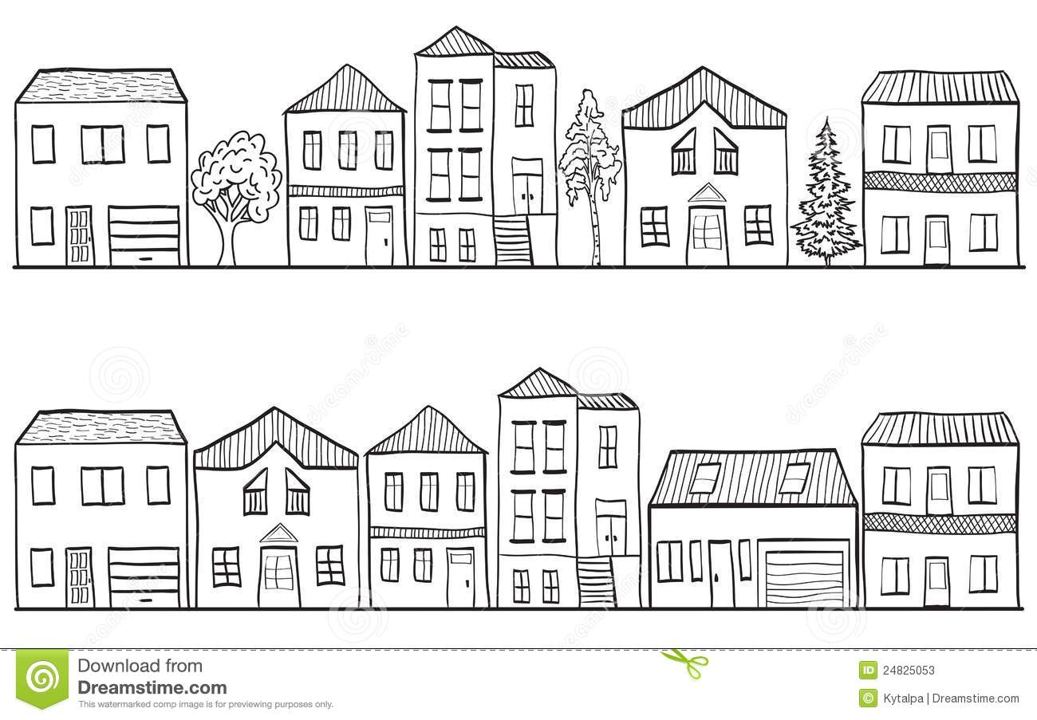

**Even**

**10**

**8**

**6**

**4**

**2**

Eraf min weg minder

Erbij plus samen meer

**Oneven**

**9**

**7**

**5**

**3**

**1**

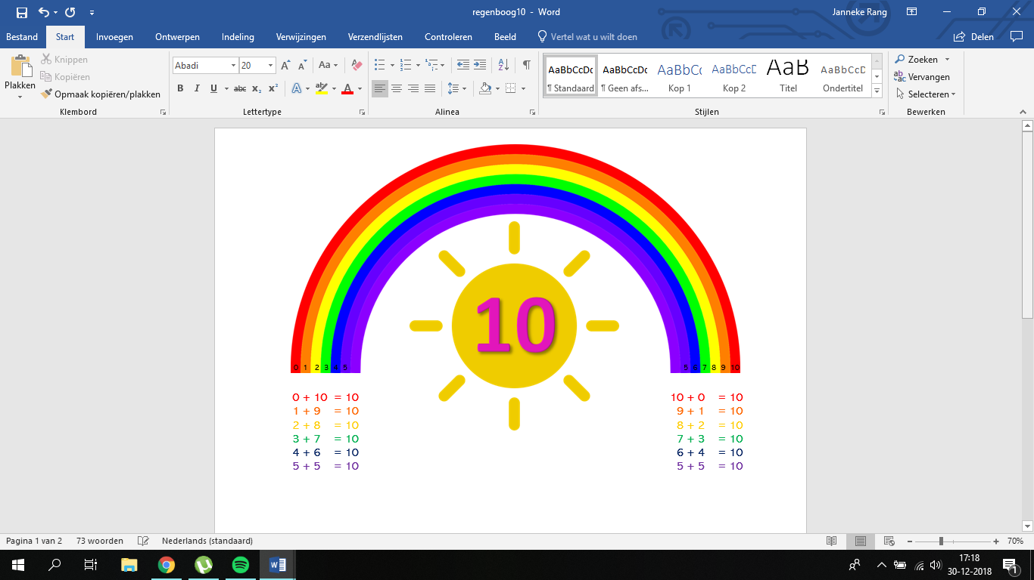

**Geld**

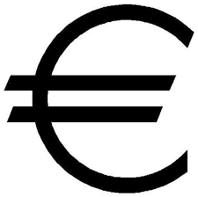

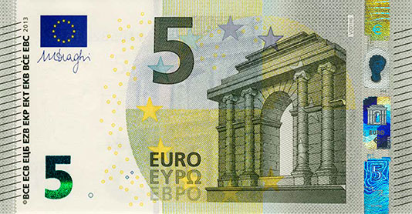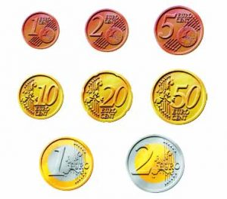

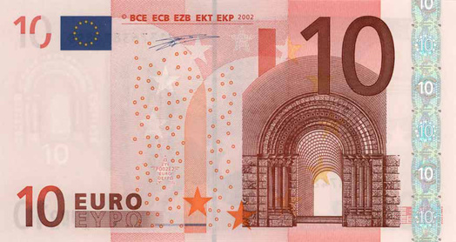

1 cent 2 cent 5 cent

1 euro 2 euro

10 cent 20 cent 50 cent

5 euro 10 euro